**Instructor Guide**

This systematic guide has been made so that you can conduct a DNA gel electrophoresis investigation with Biology I students. It is written to be used with the Modern Biology 301 lab written by John Anderson.

**Materials provided:**

**Samples:**

* Dye Mixture (300ul)
* DNA markers (120 ul)
* Unknown DNA (140 ul) The DNA is dissolved in electrophoresis sample buffer, which contains glycerol and bromophenol blue.

**Gel Electrophoresis equipment** (See pictures below as well): (6 unit’s total)

* Walter Products Power Source (75-150V)
* Power Cord
* Connecting Cables
* Walter Products Electrophoresis Chamber
* Casting Trays, Combs (3), Stoppers (4) (for making gels)

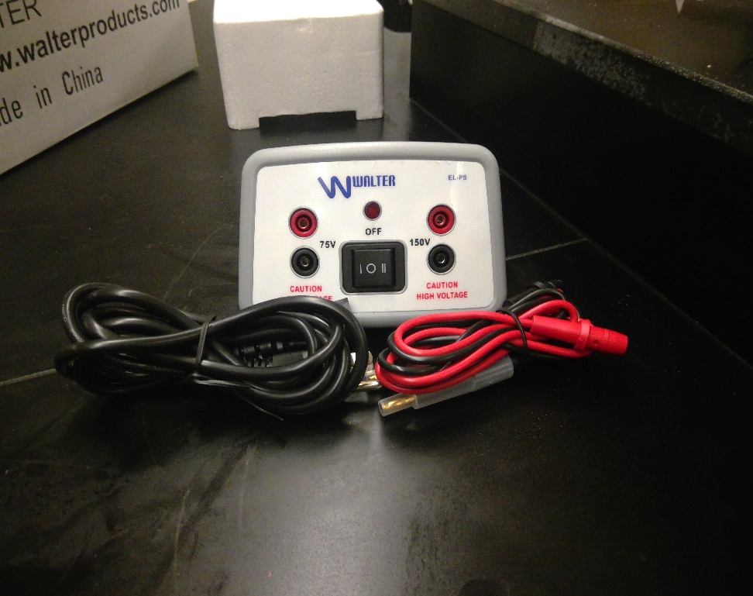 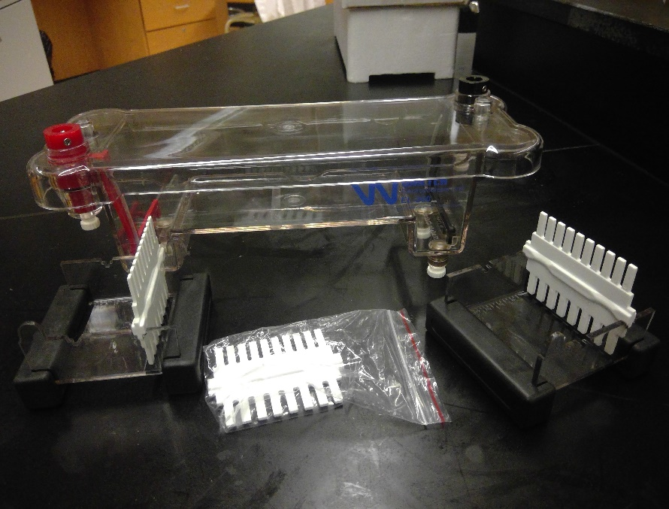

**Other:**

* Loading buffer (Tris-Acetate with EDTA) - This will be in a baggie and you will add 500 mL of DI water to make the buffer.
* Agarose with buffer- Also in a baggie (See agarose gel preparation)
* Gel Stain (Commassie Blue)
* Microcentrifuge Tubes (24 needed for 6 lab groups)

**Materials Needed:**

* 20 ul micropipettes (available on van)
* 20 uL micropipette tips (available on van)
* DI Water

**Set up for lab:**

* **Buffer Preparation:**
  + EDTA Buffer is used for moving the DNA samples within the electrophoresis chamber. Please add the EDTA powder that is provided with the lab and located in a baggie and add 500 mL of DI water to make the buffer. This buffer will then be used to run the electrophoresis units for DNA analysis.
* **Gel Preparation:** (Can be done in advance of class- Students can also make their own gels in advance depending on your schedule and what your objectives are for the laboratory)
  + Agarose for 1.2% gels can be prepared as follows (Recipe is for approximately 6 gels):
    - Agarose plus the Tris-Acetate/EDTA buffer will be in a baggie provided by the van.
    - Add DI water (labeled on the baggie) to an Erlenmeyer flask plus the Agarose baggie and mix.
    - Place in the microwave for 1 minute at a time. Swirl in between.
    - Heat just until boiling and water is clear (you should not be able to see the Agarose particles anymore)
    - Let the flask cool. You should be able to touch the flask before you pour your gels.
    - Make sure to have the comb in the gel plates as well as the black stoppers on each end like seen on the picture below.



* + - Pour the solution into the chambers and let them set and cool completely before use.
    - Remove the black rubber stoppers and comb before use.
  + If pouring gels in advance, make sure to wrap them in saran wrap with comb in place after cooled and store in refrigerator at 4°C.
* **Sample Preparation**
  + Gather 24 micro centrifuge tubes. (4 tubes per group for 6 lab stations)
  + Tube 1.5 (for each group) should include 22 uL of the Prepared Dye. (You should have 6 total when finished)- This will be placed in wells 1 and 5 in the experiment.
  + Tube 2.6 (for each group) should include 22 uL of DNA Ladder. This will be placed in wells 2 and 6 in the experiment
  + Tube 3 (for each group) should include 11 uL of unknown DNA (Tell your class that this is the DNA gathered from the Hair Sample of possible suspect) this will be placed in well 3 in the experiment.
  + Tube 7 (for each group) should include 11 uL of unknown DNA (Tell your class that this tube is the DNA gathered from the Saliva Sample of possible suspect) this will be placed in well 7 in the experiment.
* **Stain and Destain Preparation** 
  + Gather Commassie blue from supplies.
  + Place gel into Tupperware tray or shallow pan.
  + Pour enough Commassie Blue final stain into tray to just cover the gel.
  + Keep the gel in the stain for at least 20 minutes. Do not allow the gel to sit in the stain for longer than 45 minutes or it will be hard to destain.
  + Pour the Commassie Blue stain back into the original bottle (it can be reused), rinse the gel with DI water and fill the tray with just enough DI water to submerge the gel. Further destain the gel with a couple more changes of DI water at intervals of 15-30 minutes. Alternatively, the gel can be left overnight in the refrigerator to destain.
    - Notes: Do not destain with tap water or too much water or bands will fade.

**Answer key: This is a picture of what lanes 1-4 should look like after you let the gel run. Lanes 5-8 should be exactly the same as 1-4. (It is a repeat of 1-4 and therefore should be identical)**

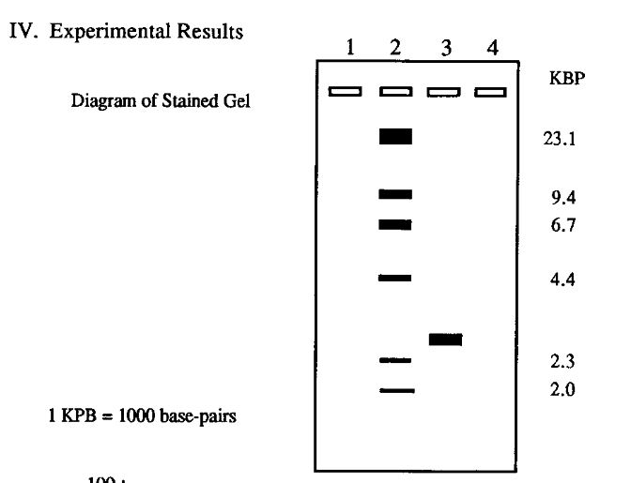

Notes: Gel Electrophoresis needs to be understood by the students to really appreciate what is happening when the base pairs separate. I would recommend that they conduct a DNA discovery gel electrophoresis lab first which will demonstrate the idea of buffers and pH and how important they are to the overall functionality of the electrophoresis equipment. I would also use the pre-lab activities described below so that students understand how smaller base pairs will travel farther in the gel and how the restriction enzymes work so that the base pairs segmentation happens and how it allows for a unique DNA fingerprint in the experiment. (NOT FINISHED)

Name: ______________________________________________ Date: __________________ Hour: _________

**The Case of Missing Purdue Pete**

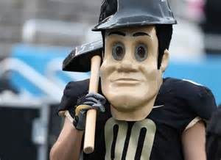Last week was the famed game between Purdue University and Indiana University. The Old Oaken Bucket was up for grabs again. Unfortunately, the game ended with a win for the Boilermakers but also a game time tragedy. The celebratory ending of the game, abruptly stopped. Purdue Pete was unexpectedly grabbed and is now missing. We are not sure what the outcome is going to be for Purdue Pete but the University is set of finding out what exactly happened to him and who committed the crime. You and your team has been contacted to conduct the investigation detailing any fingerprints and DNA that can be obtained which may lead to finding the criminal who abducted Purdue’s mascot.

**The following was found at the crime scene to help you solve the crime:**

* Purdue Pete’s famed hammer
* Fingerprints lifted off the hammer
* Water Bottle next to the hammer that has signs of saliva
* Long black hair (not color of Purdue Pete’s hair)

**Pre- Lab (Work together with your group)**

1. Before you start your investigation. Do a bit of research. What are different jobs related to forensics? List 6 (2 per person)
   1. _________________________________________________
   2. _________________________________________________
   3. _________________________________________________
   4. _________________________________________________
   5. _________________________________________________
   6. _________________________________________________
2. What are some things a DNA analyst would do? Make sure to write down where you found your information.

__________________________________________________________________________________________________________________________________________________________________________________________________________________________________________________________________________________________________________________________________________________________________________________________________________________________________________________________________

Source(s): _________________________________________________________________________________

1. Based on the evidence collected, which pieces can be used to determine a DNA fingerprint?
   1. ___________________________________________________________________
   2. ___________________________________________________________________

Now you and your team is ready to conduct the investigation. Please read the directions carefully as you walk through the steps that may lead to the person responsible for Purdue Pete missing.

**Materials: (What you will need to analyze the DNA)**

* Agarose Gels in casting trays
* Power Source
* Electrophoresis Chamber including red and black connecting wires.
* DNA ladder
* DNA samples from Crime Scene
* Sample Dye
* 20 uL micropipette
* Micropipette tips
* Beaker for used pipettes (for disposal)
* Electrophoresis buffer
* Stain
* Timer
* Data collection materials
* Wax paper
* Water

**Procedure:**

1. Obtain all materials needed to conduct investigation. Make sure to obtain agarose gels that you or a team member (or your teacher) has made previously. As well as the pre-mixed buffer solution. (Micropipettes, tips, power source, chamber, beaker will all be located at your lab group)
2. Set up Gel Electrophoresis chamber. Make sure to place gels in the tray and pour enough buffer solution to cover the gels completely. There should be 2 teams running their gels at each chamber. (Be careful of the gels as they may fall apart easily!)
3. Next obtain a micropipette and set your micropipette to 10 uL.
4. Practice using the micropipette using a piece of wax paper and the water at your table. (your teacher will show you a demo)
   1. If you pressed the micropipette passed the first stop, what did you notice about the water droplet?

____________________________________________________________________________________________________________________________________________________________________________________

* 1. If you pressed the micropipette properly each time what did you notice about the size of the drops?

____________________________________________________________________________________________________________________________________________________________________________________

1. Load 10 uL of each sample into the wells as indicated in the graphic below. The tubes will be labeled to help you place the correct ingredient in each place.

|  |  |
| --- | --- |
| Sample Well Number | Sample to be Placed in Well |
| 1 | Dye Mixture (**Tube 1**) |
| 2 | DNA Standard (**Tube 2**) |
| 3 | DNA sample (**Tube 3-** DNA from Hair) |
| 4 | Empty |
| 5 | Dye Mixture (**Tube 1)** |
| 6 | DNA Standard (**Tube 2**) |
| 7 | DNA Sample (**Tube 4**- DNA from Saliva) |
| 8 | Empty |

* 1. What was difficult about putting the sample into the wells?

______________________________________________________________________________________________________________________________________________________

* 1. What did your team do well? What did they struggle with?

_________________________________________________________________________________________________________________________________________________________________________________________________________________________________

1. Place cover on electrophoresis chamber and secure the wires. Double check to make sure that your gels are positioned so that the samples run towards the red electrodes or the positive end of the sample. Have the teacher check your work and initial that it is done correctly.

Teacher Initials: _________________________

1. Turn the power supply and place on low power. (70-85 mV is ideal)
2. Let samples migrate to positive end of chamber. Remove power supply when DNA samples have migrated to within 1 mm of the positive electrode end of the gel.
3. Remove the gels from the unit so that the gels can be stained for analysis.

**While you wait answer these questions to find out more about this process:**

What do restriction enzymes do to the DNA?

2. What is agarose gel and how does it work?

3. Where is the DNA placed in the gel electrophoresis apparatus?

4. How does electrophoresis work?

5. Bands that appear in the gel that are farther away from the starting point smaller in size than those closer to bands that are near the starting point. Why is that?

Name: ________________________________________ Date: ________________________ Hours: _______

**Analysis:**

Draw what your Gel looked like after it was stained: The numbers below stand for the sample wells.

|  |  |  |  |  |  |  |  |
| --- | --- | --- | --- | --- | --- | --- | --- |
| 1 | 2 | 3 | 4 | 5 | 6 | 7 | 8 |
| Dye | DNA Ladder | Hair Sample | Empty | Dye | DNA Ladder | Saliva | Empty |

Now that we have results it is time to figure out if one of our suspects is the person who abducted Purdue Pete.

When the incident occurred, people at the scene were asked for a possible description of who the abductor might have looked like. All accounts said they saw a young Caucasian man in the area that was around 6 ft. tall and had dark hair at the time of the abduction. After many interviews and sketches 4 suspects have been brought in for questioning and DNA analysis. Your job is to analyze the 4 suspect’s motives and DNA to see which fits the best.

Look at the following 4 subjects and their DNA fingerprint. Then decide who the criminal is. Finally answer the questions.

**Suspect 1** – Nicholas de Notre Dame

***General Information and MO (Motive)***

Nicholas is a 6 ft. 2 Caucasian Junior from South Bend, IN and attends Notre Dame. He has brown hair and brown eyes. He originally wanted to be in Purdue’s engineering school but was denied admission. He is doing well at Notre Dame but always wants Purdue to lose. His friend invited him to the game and he decided to watch IU vs. Purdue. He rooted for IU and was not happy that Purdue won the game.

**Question:**

What information makes this man a suspect? ____________________________________________________________________________________________________________________________________________________________________________________________________

What is Nicholas’ motive? ____________________________________________________________________________________________________________________________________________________________________________________________________

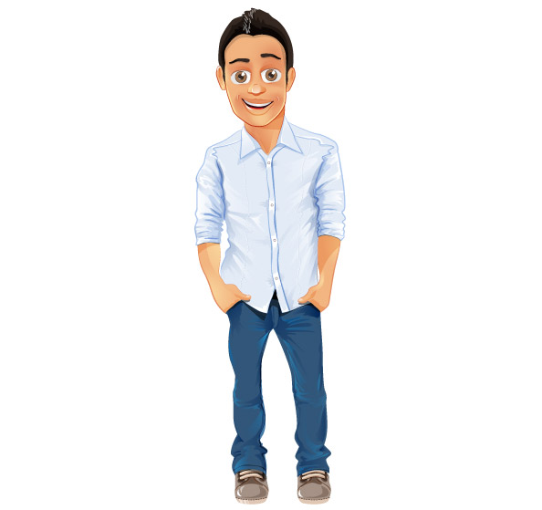**Suspect 2- Cameron Lafayette**

***General Information and MO (Motive)***

Cameron is a 5 ft. 11 Caucasian man from Lafayette, Indiana. Until last semester he was a student at Purdue but failed out of the biotechnology program due to not attending classes and has been seen frequenting many local hangouts. He was supposed to graduate in May. He has brown hair and light eyes. Cameron has always loved Purdue but has recently been upset with the school because he believes they are responsible for his bad fortune. He still claims to love Purdue football and went to the game supporting his Boilers to win the Old Oaken Bucket.

**Question:**

What information makes this man a suspect? ____________________________________________________________________________________________________________________________________________________________________________________________________

What is Cameron’s’ motive? ____________________________________________________________________________________________________________________________________________________________________________________________________

****Suspect 3- David Butler**

***General Information and MO (Motive)***

David is a 6 ft. Caucasian man from Indianapolis and is a freshman at Butler University. His brother plays football for IU and was dressed in IU Crimson and White for the game. He despises Purdue and Purdue football. He thinks Purdue Pete is a lame mascot and let everyone in the crowd know about it at the game. He was so loud and rude that he got thrown out of the game in the 3rd quarter and was not allowed back into his section. He secretly snuck into another section and kept quiet the rest of the game. He also has brown hair and light eyes.

**Question:**

What information makes this man a suspect? ____________________________________________________________________________________________________________________________________________________________________________________________________

What is David’s’ motive? ____________________________________________________________________________________________________________________________________________________________________________________________________

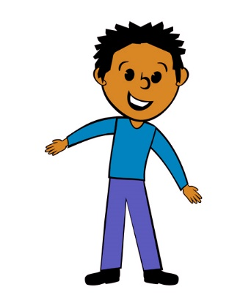**Suspect 4- Brad Bloomington**

***General Information and MO (Motive)***

Brad is an avid IU fan. He also is an African American man who is a sophomore at IU majoring in biology. He came to the game hoping that IU would win but they were crushed 48 to 3. He was very upset at the game and said Purdue will suffer. He also has brown hair and brown eyes.



**Question:**

What information makes this man a suspect? ____________________________________________________________________________________________________________________________________________________________________________________________________

What is Brads’ motive? ____________________________________________________________________________________________________________________________________________________________________________________________________

After looking at these suspects is there anyone we can probably eliminate from our list? _________________________

Why? ____________________________________________________________________________________________

Can we definitely eliminate him? Why not? ___________________________________________________________

**DNA Fingerprint Analysis:**

Analyze the following DNA fingerprints that were taken from the suspects above. Then compare them to your DNA fingerprint to find our criminal.

Suspect 1- Nicholas de Notre Dame Suspect 2- Cameron Lafayette

1 2 3 4 5 6 7 8

1 2 3 4 5 6 7 8



Suspect 3: David Butler Suspect 4: Brad Bloomington

1 2 3 4 5 6 7 8

1 2 3 4 5 6 7 8



**Questions:**

Based on your analysis who is the criminal that abducted Purdue Pete? How can you tell? ____________________________________________________________________________________________________________________________________________________________________________________________________

How does DNA gel electrophoresis help a forensic scientist confirm either guilt or innocence in a criminal investigations? ____________________________________________________________________________________________________________________________________________________________________________________________________

**Compare your results to other groups in your class. Then answer these questions:**

Did you get the same result: Yes or No? __________________

If you got the same results how does this help prove that the criminal in fact is the real criminal?

____________________________________________________________________________________________________________________________________________________________________________________________________

Why is replicating results in a forensic investigation or any scientific work important? ____________________________________________________________________________________________________________________________________________________________________________________________________

Did any groups (including your own) not get results or got different results? ____________________________________

What possible errors could have led a group to not getting results or getting different results than the rest? ___________________________________________________________________________________________________________________________________________________________________________________________________

Is failure ok in science? Why? ________________________________________________________________________

_________________________________________________________________________________________________

What are two important things you learned from this experiment. ____________________________________________________________________________________________________________________________________________________________________________________________________

What scientific skills did you need to conduct this investigation? ____________________________________________________________________________________________________________________________________________________________________________________________________